

PROJECT REPORT
“SHORTEST DELIVERY ROUTE MANAGEMENT”

- Gautam Sanjay Wadhwani– 19BCE1209
- Shreeharsh Pandey – 19BCE1818
- Harsh Sharma – 19bce1464

CSE 2003

DATA STRUCTURES AND ALGORITHMS

Under the guidance of

Mam Richa Singh B V

2020-2021

B. Tech

in

COMPUTER SCIENCE AND ENGINEERING

OBJECTIVE

Our project intends to contribute to solutions for the growing industrial need to design reliable and efficient time dependent systems. In particular, it intends to provide theory and tools for shortest delivery route management, control and optimisation of real-time distributed systems. Its approach will be based on calculating shortest distance, providing graph and it also helps to distribute coordinates of delivery among several delivery persons that is efficient for the work order. Tools that can be a basis for an industrial design practice of such systems. In addition to its technological contributions, Our Project invests actively in knowledge to the Restaurants industry of computer-aided timing analysis and design. Moreover, it is expected that the Our project research results will influence and advance the field of shortest path and delivery route, and (indirectly) contribute to the food industry. The aim of our project is to advance and mature the related models, tools, and methods to allow this situation to change.

INTRODUCTION

After thinking about what kind of application program we wanted to create, we did research into the existing work in both the application areas as well as the typical data structures that are used. Seeing the current pandemic situation where we got to learn about our basic need the first thing pops out was food. It’s hard to deliver food essentials to the different places efficiently as per taking the time as constraints. The data structure of choice and learnt more about how they work and the different implementation choices. The program covers 4 different usecases – to understand and implement the shortest path between coordinates, to generate the graph of the distance and the last part is based on helping out the person who is going to deliver the items as sorting out the coordinates of delivery among delivery person based on the distance of the coordinates. When our inputs will be in adjacency matrix then it will be helping us out to give the optimal path.
The rest of this document goes into more detail about the project and the background research done.

IMPLEMENTATION:

DSAproj.ipynb

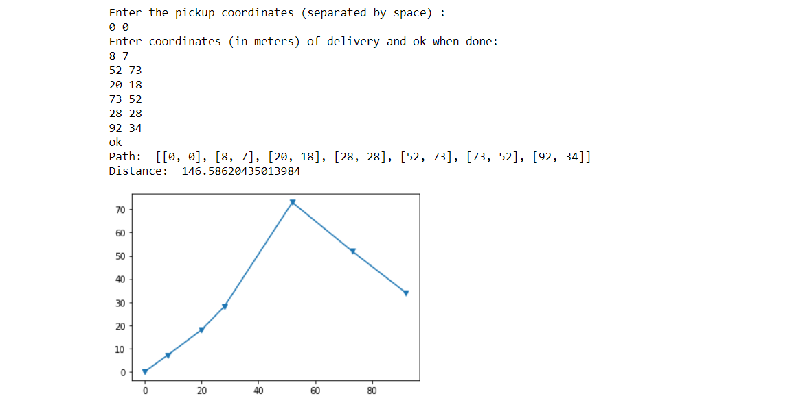
Second case

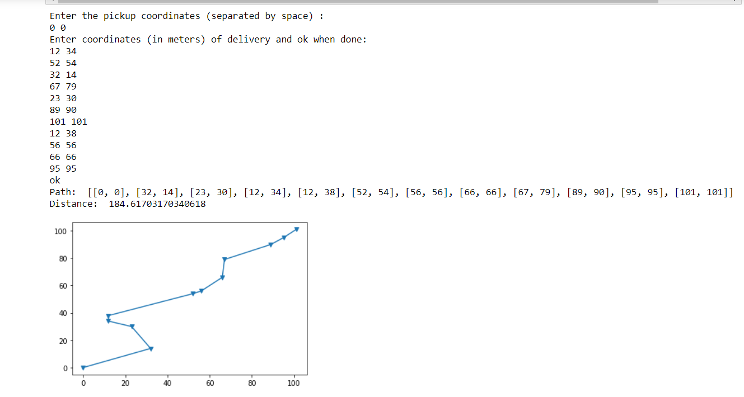

Third case –

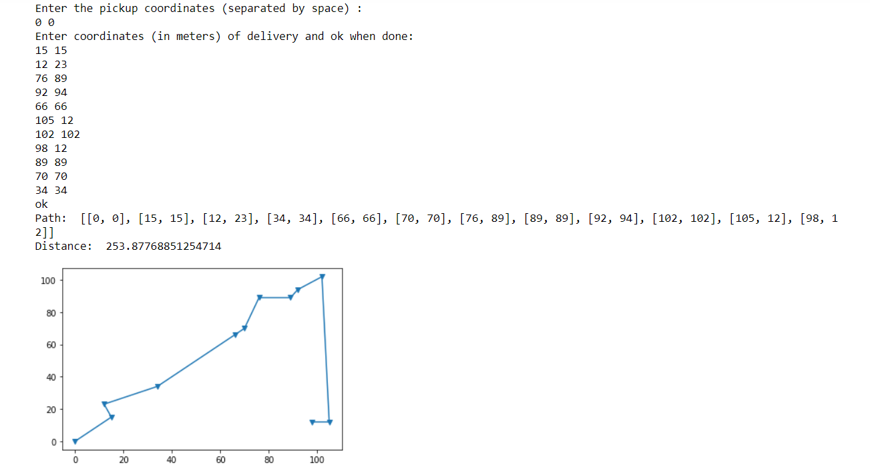

divide orders.py-

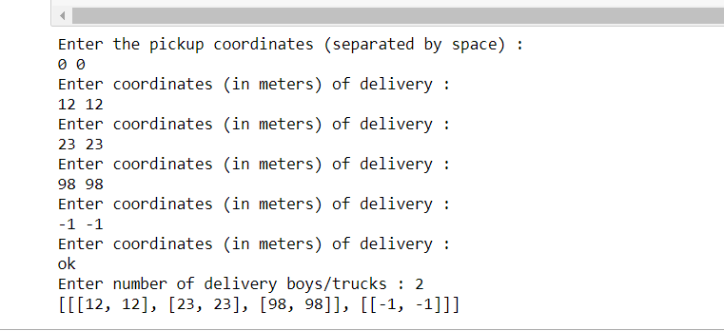

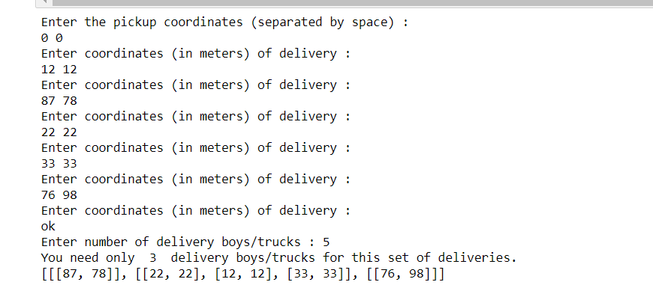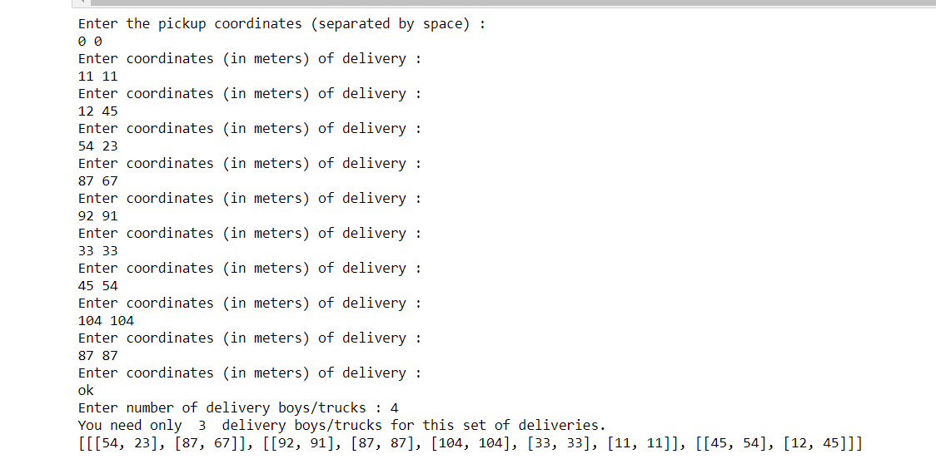

Shortest path graph input.py
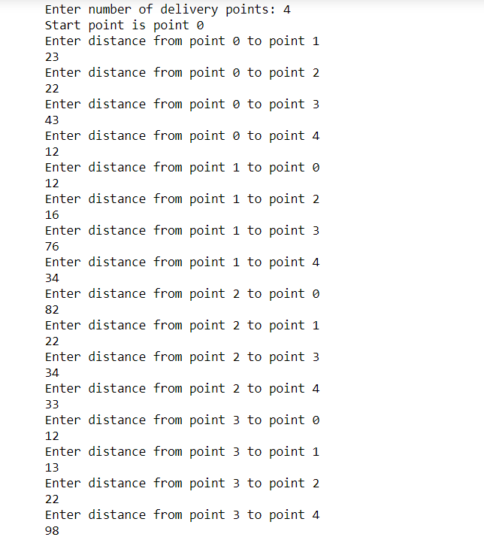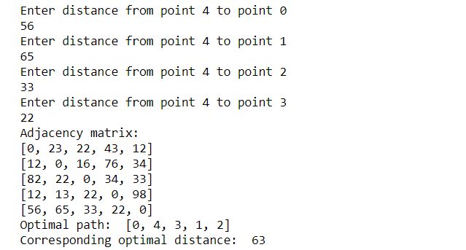

USE CASES

- Shortest Path for Coordinates as Inputs.
- Shortest Path for Graphs (adjency matrix) as Inputs
- To divide the delivery coordinates among different delivery person suitable.

EVALUATION

- Brute Force Method

- Start point is taken as input then all the coordinates where delivery is to be done are taken as input.
- Try all the permutations of the coordinates except the start point and find the shortest path covering all the coordinates and the corresponding shortest distance.
- A recursive function is used to find all possible permutations of the list of delivery points.
- The advantage of this method is that we get an exact answer.
- The disadvantage is that since we need to try all possible permutations, the time complexity is O(n!) which is too high.
- This algorithm can be used for n<8 for which it took around 30 seconds to run.

- Optimization of this method

- We need to traverse through the list of permutations generated and find the distance for each permutation.
- If at any point, the distance until that point is more than or equal to the minimum distance recorded so far, break the loop since it will lead to a longer path so no need to calculate the total distance for that particular path.
- We will still get an exact answer but the time complexity is still not much affected.
- So for n>=8, we use approximate greedy method.

- Greedy Method

- First make a copy of the input list of coordinates.
- Go to the nearest point from the start point and find the distance.
- Now new start point is that nearest point and delete it from the copy of the list.
- Now go to the next nearest point and continue until the copy list becomes empty.
- The time complexity of this method is O(n^2) but it will not always lead you to the shortest path.

- Improvement in the answer

- There are 3 methods to improve the answer obtained by the greedy method
- First is to pick up the last point of the route and put as the second point of the route and check whether the distance is reduced.
- Continue the same process until there is no more improvement or a counter variable reaches a big enough number say 40,000/n.
- This will require O(n) time.

- In the second method, we take a counter variable initialized to 0 then pick up any random point (except the second point and the last point) and place it at the second position and check whether this change caused an improvement in the total distance to be travelled to cover all the points.
- If there is an improvement, we continue until there is no more improvement or the counter variable reaches a value say 40,000/n^2.
- Time required is O(n^2).

- In the third method, we take a counter variable initialized to 0 then pick up any two random points and swap them in the list and check whether this change caused an improvement in the total distance to be travelled to cover all the points.
- If there is an improvement, we continue until there is no more improvement or the counter variable reaches a value say 40,000/n^3.
- Time complexity is O(n^3).
- These three optimizations can cause much improvement in the accuracy of the answer.

- Another approximate method

- Sort the coordinates on the basis of polar coordinate on shifting the origin to the start point.
- Point with smaller angle put first.
- If angle is same then the point nearer to the previous point in the sorted list put first.
- Use mergesort algorithm with O(n log(n)) time complexity.
- Check whether the list when taken in reverse has more or lesser total distance keeping the start point at index 0 only and select the one with lesser total distance.
- The answer can be improved using the same methods discussed above.
- Select the better answer among improved answer of greedy algorithm and improved answer of this approximate method.

- Using Graph DS to solve

- The above methods work only when the distance from one point (say A) to another (say B) is same as the distance from B to A.
- But sometimes the distance from B to A can be different if there is a one way.
- And sometimes the distance is not just the straight line distance.
- So we can use a graph data structure to input the distance between all pairs of points in the form of an adjacency matrix.
- For simplicity we name the edges as 0,1,2,3…
- So we input only the adjacency matrix.

- Brute Force on Graph

- Generate all possible permutations of the numbers 1,2,3… n-1 in a list per. 0 represents the start point.
- Traverse through per
- The length of each permutation is n-1. Initialize distance to be graph[0][per[i][0]] (distance of start point to first point in i^{th} permutation). Now traverse through the i^{th} permutation and take j=1 to j=n-2. Add graph[per[i][j]][per[i][j+1]] to the distance.
- Find the total distances of all permutations and select the permutation with least distance as the optimal path.
- Time complexity is O(n!).

- Greedy Method on Graph

- Make a copy of the adjacency matrix.
- Go to the nearest point from the start point and store the distance.
- Go to the next nearest point, add the distance between these points and delete the start point (delete all edges that contain it) and mark that nearest point as the new start point.
- Continue the above process until the copy of the adjacency matrix is emptied.
- Deletion reduces the complexity by a factor of n since we no longer need to check whether the point has already been visited because we delete the point after visiting at each iteration.
- Time complexity is O(n^2).

- Improvement of Greedy Method on Graph

- Since the result of greedy method is not always optimal, we can use the three methods used on greedy algorithm with coordinates as input on the greedy algorithm with graph as well.
- First is to pick up the last vertex of the resultant path and put as the second vertex and check whether the distance is reduced.
- Continue the same process until there is no more improvement or a counter variable reaches a big enough number say 40,000/n.
- This will require O(n) time.
- In the second method, we take a counter variable initialized to 0 then pick up any random vertex (except the second and last vertices) and place it as the second vertex and check whether this change caused an improvement in the total distance to be travelled to cover all the points.
- If there is an improvement, we continue until there is no more improvement or the counter variable reaches a value say 40,000/n^2.
- Time required is O(n^2).

- In the third method, we take a counter variable initialized to 0 then pick up any two random vertices and swap them in the list and check whether this change caused an improvement in the total distance to be travelled to cover all the points.
- If there is an improvement, we continue until there is no more improvement or the counter variable reaches a value say 40,000/n^3.
- Time complexity is O(n^3).
- These three optimizations can cause much improvement in the accuracy of the answer.
- Since we don’t know the exact coordinates of the vertices in a graph DS, we cannot use the method that sorts on the basis of polar coordinates. This can be done if both graph and coordinates are taken as input.
CONCLUSIONS

- We have three python programs.
- First is for finding an optimal route for input coordinates.
- Second is for finding an optimal route for input graph.
- Third is to divide different coordinates among the delivery boys such that the deliveries are completed faster.
- This project finds a fairly optimal solution for an NP Hard problem similar to the famous TSP in polynomial time.

References

Books

- Introduction to Algorithms by Cormen, Leiserson, Rivest and Stein

- C++ Primer Plus, by Stephen Prata

Internet sources
- http://web.stanford.edu/class/archive/cs/cs166/cs166.1146/
lectures/09

/Small09.pdf
- https://www.geeksforgeeks.org/data-
structures/ ·

